**Grade 10 Intro to Applied and Pre-Calculus Math (20S)** Glenella School

Course Code: 3905 Term I – 2025/2026

Credit Value: 1.0 credits

Instructor: **Mrs. L Frohwerk**  **contact info**: lfrohwerk@trsd.ca

**Course Outline**

**Course Description:**

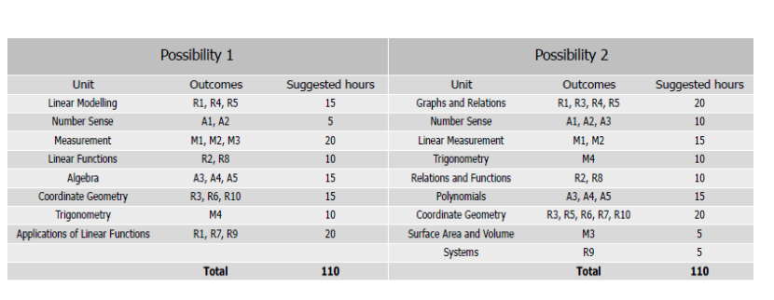Grade 10 Introduction to Applied and Pre-Calculus Mathematics (20S) is intended for students considering post-secondary studies that require a math pre-requisite. This pathway provides students with the mathematical understanding and critical-thinking skills that have been identified for specific post-secondary programs of study. The topics studied form the foundation for topics to be studied in both Grade 11 Applied Mathematics and Grade 11 Pre-calculus Mathematics.

Please note that the order and time spent on the units of study may not follow the above listing and are at the discretion of the instructor. Each class we have is approximately 70 minutes, so a 20-hour unit on Measurement will take around 17 classes.This includes tests, lessons and work classes. **You have to do your work and keep caught up.**

**Mark Distribution:**

**Final exam – 30% (Week of January 26th)**

**Course Work** – **70%**

**Course Work** may include any/all of the following:

**Hand In Assignments:** Hand in assignments will be given for each unit. Students are to work on the hand in assignment **in class only** and without access to technology (laptop and cell phones). Students are able to use their notes for assistance when working on the assignments.

**Tests** will be given at the end most units. Some of the longer units may have more than one test. You must have the review for the unit completed before you write the test. All tests will be written with the aid of a **one-sided** student created study sheet. No student should have an identical study sheet as someone else. If this occurs, neither student will be allowed to use the study sheet.

**Final Exams** will be written by all on the day and time scheduled. The final exam is will cover all the outcomes in the course.

**Materials**

* Binder & dividers
* Laptop and headphones*
* Scientific Calculator
* Pencils, eraser, ruler

**\*Students will use Teams to access the videos for their notes and to access the digital textbook. They will need to bring it to every class.\***

**Classroom Expectations:**

* Students are expected to arrive for class on time and prepared (with all required materials).
* If a student is absent from class, prior notice should be given and any missed work must be completed immediately after the student returns to class. It is the student’s responsibility to ensure all missed work is completed.
* All assignments are to be completed to the best of the student’s ability. Substandard work will not be accepted and the student will be required to redo the assignment properly.
* This is a senior 2 level course and students are expected to behave as responsible young adults. As principal duties may require my absence from class on occasion, students are expected to be able to work independently and with limited supervision. This includes being self-sufficient on occasions where I am unable to attend the start of class or am called away during scheduled class time.
* **Do your best & be respectful!**

**Plagiarism/Cheating Policy:**

The school handbook outlines the expectations in regards to academic dishonesty (If at any time you are unsure about an assignment it is the student’s responsibility to ask for clarification), attendance and the use of technology including AI.

1st offence- The student will receive a zero (0) on the assignment. A phone call/email will be sent to the parent/guardian.

2nd offence- A letter will also be sent home to the parent/guardian. The parent/guardian must sign the letter and return it to the school. The Student will receive a zero (0) on the assignment.

3rd offence- The student will receive a zero (0) on their assignment and they will be referred to the principle for further disciplinary action. A meeting will need to be arranged with the parent/guardian to address the severity of this issue.

**Extra Help:**

If a student requires extra help on a particular assignment/topic we covered in class, it is up to the student to request a meeting with the teacher.

**Outline Confirmation and Contact Information:**

Communication with parents is more important than ever and will be a priority. For parents that have access already, I encourage you to use the Edsembli parent portal. After you go over this outline with your student, be sure to date, sign and provide me with your contact information. Please clearly indicate which method of communication you would like me to contact you with, and which parent/guardian to address my inquiries to. If both every parent/guardian would like the information than feel free to include them. You can fill out the form below (add more spaces if needed), but I personally would prefer you send me an email ([lfrohwerk@trsd.ca](mailto:lfrohwerk@trsd.ca)) with all the information so that I can ensure it is not misplaced.

I have read this outline over, and discussed it with my parent(s)/guardian(s) and understand what it contains. By getting these signatures, and appropriate contact information. Feel free to contact me via email at [lfrohwerk@trsd.ca](mailto:lfrohwerk@trsd.ca) if you have any questions, or phone the school to arrange a meeting (352-4253).

_________________________ __________________________ _________

Parent/Guardian Signature Students Signature Date

Parent email(s): ____________________________best phone number for contact: _______________