**Grade 11 Essentials of Math 30S**  Glenella School

Course Code: 3000 Term I – 2025-2026

Credit Value: 1.0 credits

Instructor: **Mrs. L. Frohwerk**  **contact info**: lfrohwerk@trsd.ca (204)352-4253

**Course Outline**

**Course Description:**

Grade 11 Essentials of Mathematics (30S) is intended for students whose post-secondary planning does not include a focus on mathematics and science-related fields. Grade 11 Essentials of Mathematics is a one-credit course consisting of two half-credits each emphasizing consumer applications, problem solving, decision making, and spatial sense.

Grade 11 Essentials of Mathematics builds on the knowledge and skills gained from Grade 10 Essentials of Mathematics and provides a foundation for the topics studied in Grade 12 Essentials of Mathematics.

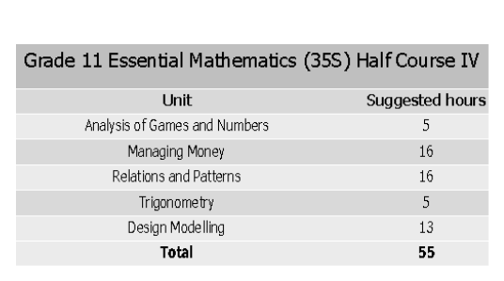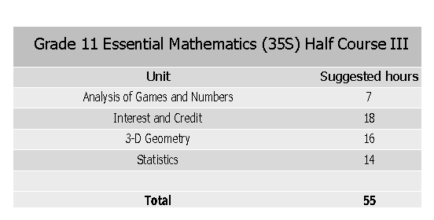Students are expected to work both individually and in small groups on mathematical concepts and skills encountered in everyday life in a technological society.

Please note that the order and time spent on the units of study may not follow the above listing and are at the discretion of the instructor.

Each class we have is approximately 70 minutes, so a 16-hour unit on Managing Money will take around 14 classes.This includes tests, lessons and work classes. **You have to do your work and keep ahead.**

**Mark Distribution:**

**Final exam – 30% (week of January 26, 2026)**

**Course Work** – **70%**

**Course Work** may include any/all of the following:

**Hand In Assignments**: Students will be given hand in assignment(s) for each unit. Students must complete these assignments **in class**. Students will have access to their notes but will not have access to technology such as their laptop or cell phone.

**Homework:** The course work for each unit will mainly be worksheets or textbook questions. Students will have access to the answer keys for them to check their answers.

**Tests** will be given at the end most units. Some of the longer units may have more than one test. You must have the review for the unit completed before you write the test. All tests will be written with the aid of a **one-sided** student created study sheet. No student should have an identical study sheet as someone else. If this occurs, neither student will be allowed to use the study sheet.

**Final Exams** will be written by all on the day and time scheduled. The final exam is typically a divisional exam.

**Class Expectations:**

Students are expected to arrive for class on time and prepared (with all required materials).

* If a student must be absent from class, prior notice should be given and any missed work must be completed immediately after the student returns to class. It is the student’s responsibility to ensure all missed work is completed.
* All assignments are to be completed to the best of the student’s ability. Substandard work will not be accepted and the student will be required to redo the assignment properly.
* This is a senior 3 level course and students are expected to behave as responsible young adults. As principal duties may require my absence from class on occasion, students are expected to be able to work independently and with limited supervision. This includes being self-sufficient on occasions where I am unable to attend the start of class or am called away during scheduled class time.
* Do your best & be respectful!

**Plagiarism/Cheating Policy:**

The school handbook outlines the expectations in regards to academic dishonesty (If at any time you are unsure about an assignment it is the student’s responsibility to ask for clarification), attendance and the use of technology including AI.

1st offence- The student will receive a zero (0) on the assignment. A phone call/email will be sent to the parent/guardian.

2nd offence- A letter will also be sent home to the parent/guardian. The parent/guardian must sign the letter and return it to the school. The Student will receive a zero (0) on the assignment.

3rd offence- The student will receive a zero (0) on their assignment and they will be referred to the principle for further disciplinary action. A meeting will need to be arranged with the parent/guardian to address the severity of this issue.

**Late Assignment Policy:**

Assignments are expected to be handed in assignments on the due date. Late assignments will only be accepted by the teacher’s discretion. It is up to the student to communicate with the teacher if they cannot complete the assignment on the expected due date.

**Extra Help:**

If a student requires extra help on a particular assignment/topic we covered in class, it is up to the student to request a meeting with the teacher.

I have read this outline over, and discussed it with my parent(s)/guardian(s) and understand what it contains. By getting these signatures, and appropriate contact information. Feel free to contact me via email at [lfrohwerk@trsd.ca](mailto:lfrohwerk@trsd.ca) if you have any questions, or phone the school to arrange a meeting (352-4253).

_________________________ __________________________ _________

Parent/Guardian Signature Students Signature Date

Parent email(s): ____________________________best phone number for contact: _______________