**Ste. Rose School**

**2025-2026**

**Grade 5 Supply List (Please label items with child’s name)**

* pencil case
* pencils (12)
* blue pens (2)
* 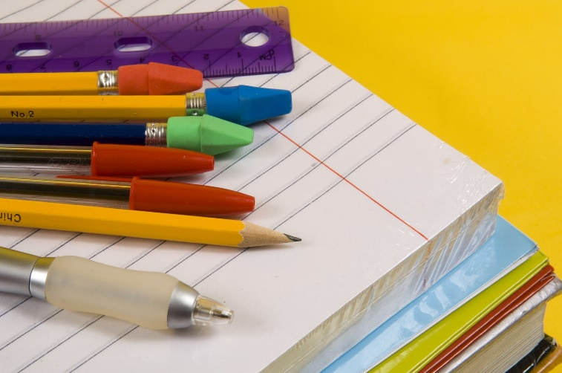red pens (2)
* pencil crayons
* erasers (2)
* glue stick
* ruler (30 cm)
* 5” scissors
* dry erase markers (2)
* highlighter marker(1)
* basic calculator
* homework folder
* 2-inch binders (4)
* duo-tangs (1 bleu, and 1 red)
* loose-leaf paper (2 packets)
* graph paper (1 pack)
* hilroy scribblers (2)
* coiled notebook (2)
* gym clothes (deodorant, t-shirt, shorts or sweat pants)
* indoor runners (non-marking soles for gym floor)
* boxes of Kleenex (2)
* 1 non-spillable water bottle
* headphones or ear buds
* backpack/lunch kit

Thank you,

Mr. Vandepoele – Grade 5 Teacher